Name: Trần Tiểu Bình  
Student ID: 1752010

Date: 12 April 2020

**HOMEWORK**

Draw a general and Grafcet flowchart for the traffic lights with the requirements:  
Green: 15s, Yellow: 5s, Red: 20s.

**General flowchart**

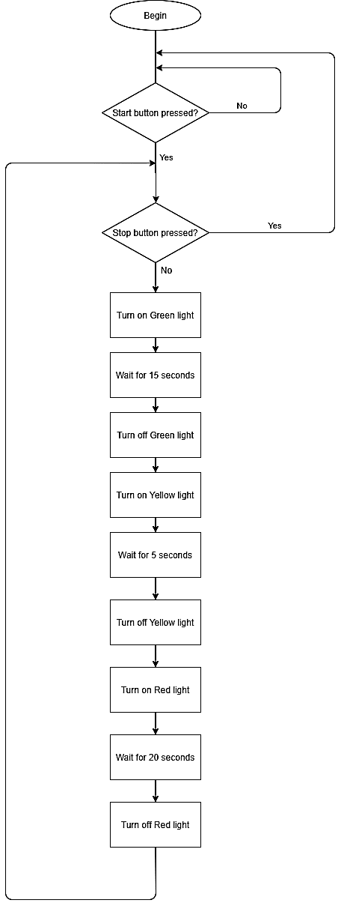

**Grafcet flowchart**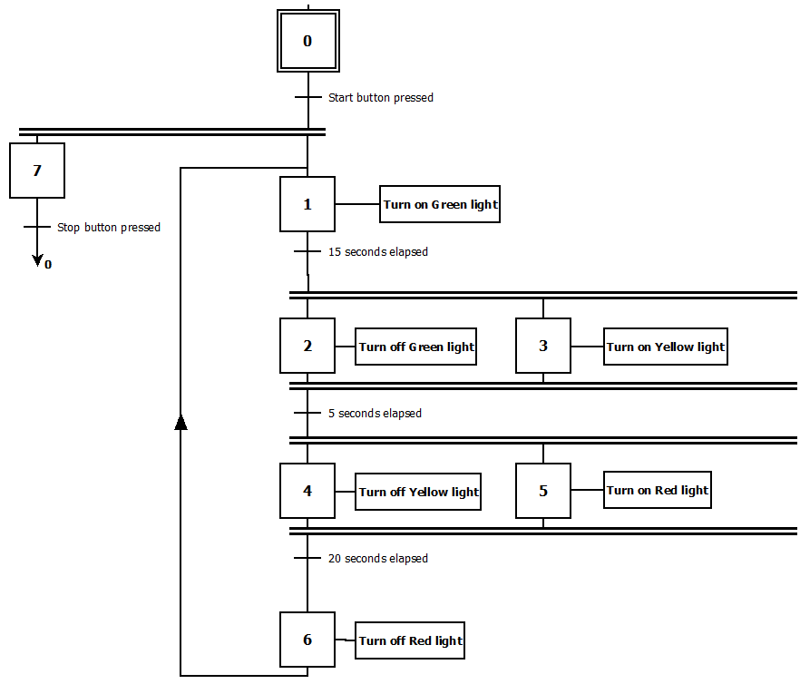

The stop buttons in two flowcharts have different meanings. The stop button in Grafcet illustrates an interruption, which means when we press it, the program moves to step 0 immediately. However, when we press stop button in general flowchart case, the program still runs until the end of the loop (Red light turns off), starts a new loop, checks the condition again and then performs it.